Lab 07

BJT as Switch and Emitter-Follower Amplifier
Name: Syed Sualeh, Syed Haider | Student ID: 10303, 10270

Objective
To investigate the operation of BJT common-collector (emitter-follower) amplifier and design a circuit for LED control using BJT as a switch.
Note: Pre-lab (printed or hand-written) should be done on a separate paper (use A4 sheet) and will be submitted at the start of Lab within first 10 minutes.

Pre-Lab Task
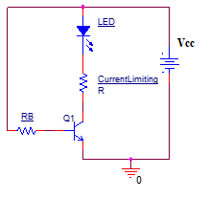

Task 1: To derive expressions for designing BJT switch controlling LED.
- For the circuit given above derive the expressions for the base resistor $R_{B}$ and the current limiting resistor $R$ using KCL.
- Given that the forward voltage $V_{LED }$and current through LED is 2V and 20mA respectively, what will be the value of collector current $I_{C}$.
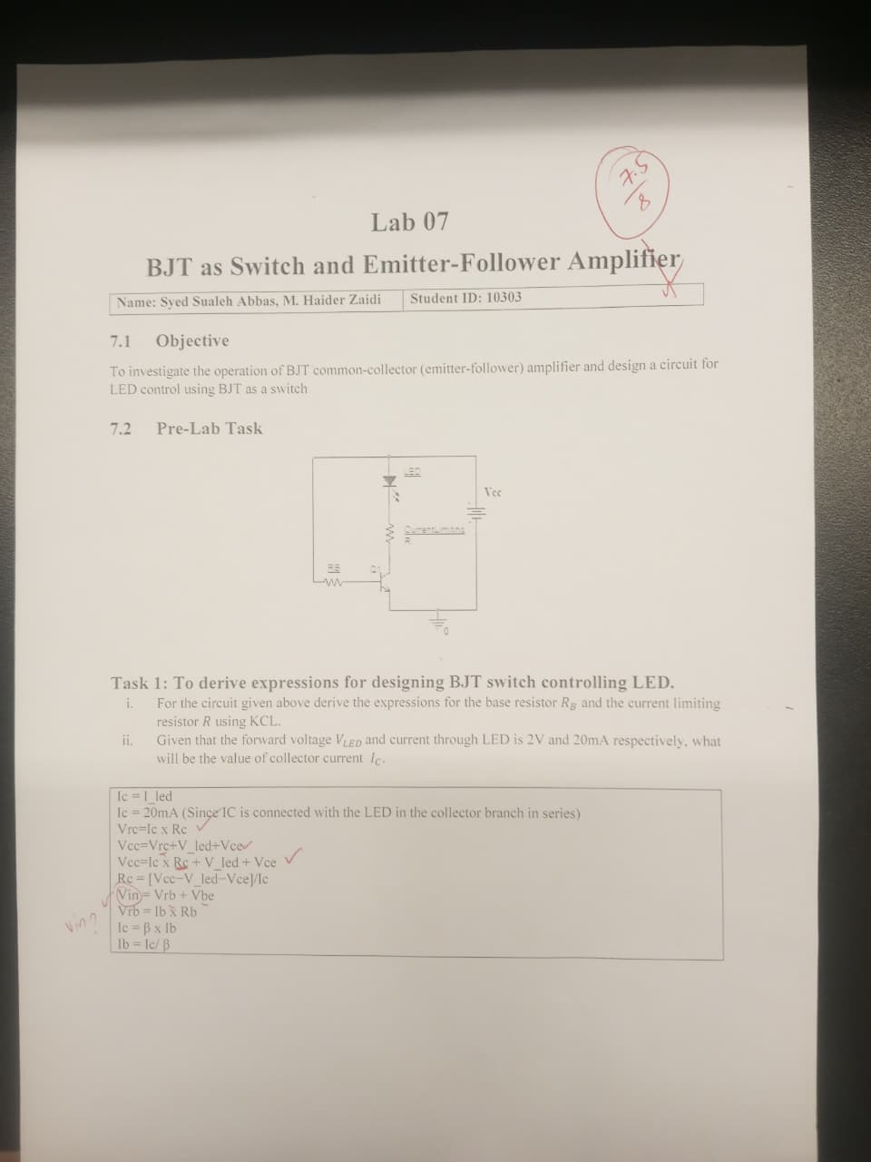

Introduction to Emitter-Follower Common Collector Amplifier
When the output of BJT amplifier is taken from the emitter terminal of the transistor as shown in Figure 1, the network is referred to as an emitter-follower. This configuration is actually a common-collector configuration because the collector is directly connected to supply and this will be grounded for AC analysis. The emitter-follower configuration is frequently used for impedance-matching purposes.
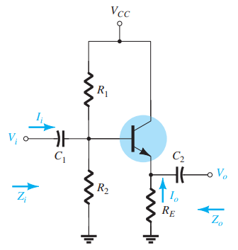
Figure 1: Emitter-follower amplifier circuit
For the circuit shown in Figure 1, if BJT is replaced by its r_{e} model, the AC equivalent of the network can be represented by Figure 2. Here, R’ is the equivalent impedance R1 || R2.
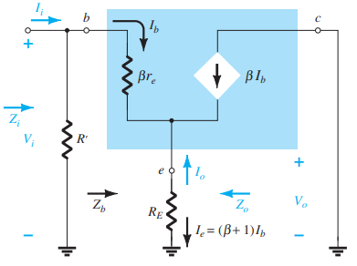
Figure 2: AC equivalent of the emitter-follower network

Characteristic Parameters of Emitter-Follower CC Amplifier
Using the network of Figure 2, the characteristic parameters of emitter-follower circuit are given as:
- AC Voltage Gain Av is defined as
Here, Vo and Vi are output and input voltage which can be measured as rms, peak or peak-to-peak.
From model, the AC voltage gain of a CC amplifier (under no-load) can be calculated using:
Where, transistor AC dynamic resistance r_{e} shown in model can be calculated as
- AC Input Impedance, Zi, is that of the amplifier as seen by the input signal. For CC amplifier, it can be given as
- AC Output Impedance, Zo, for CE amplifier can be approximated to

Task 2: To determine DC operating point of transistor for emitter-follower amplifier
- Implement the circuit shown in Figure 3 using 2N3904 BJT model and supply of 10V.
- Note down the measured values of resistances used in your implemented circuit.
- Measure the DC operating values of the circuit as given in Table 1.
Table 1: DC operating point of BJT in CC amplifier circuit
Parameters | Measured Value | Parameter | Measured Value | Parameter | Measured Value
V_{CC} | 10V | Base Voltage: V_{B} | 2.23V | Base Current: I_{B} | 7.6u
R1 | 33.04k | Emitter Voltage: V_{E} | 2.53V | Collector Current: I_{C} | 1.599m
R2 | 11.5k | Collector Voltage: V_{C} | 10.035V | Emitter Current: I_{E} | 1.66m
R_{E} | 0.98k | Base-Emitter Voltage: V_{BE} | 0.66V | DC Current Gain: β | 210.395
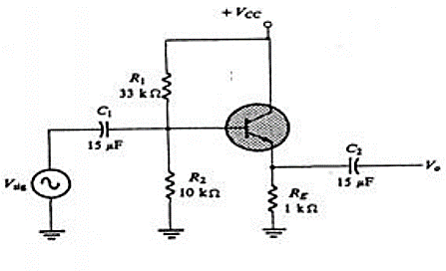
Figure 3: Emitter-Follower CC amplifier circuit for implementation

Task 3: To calculate the characteristic parameters of emitter-follower amplifier
- Now, using the measured values of Table 1, calculate the characteristic parameters of amplifier listed in Table 2.
Table 2: Characteristic parameters of CC amplifier circuit
Parameters | Calculated Values
Transistor AC dynamic resistance r_{e} | 15.66
AC Voltage Gain Av | 0.9843
Input Impedance Zi | 8.1969k
Output Impedance Zo | 15.66

Task 4: To experimentally determine characteristic parameters of emitter-follower CC amplifier
- Complete the amplifier implementation, and apply AC input signal V_{sig} of 1Vrms (1.414V peak) at frequency of 1k Hz at no load condition through coupling capacitor C1. Measure the output voltage through C2 at no-load. Make sure there is no distortion or clipping of waveform at the output terminal emitter.

Amplifier Voltage Gain: Av
- Obtain the waveforms of input and output voltage. Note down their measured values in Table 3. Determine the gain of amplifier.
- Observe the phase difference between the two and assign corresponding sign (+/-) to the gain.

When the input and output waveforms were observed on the oscilloscope, both signals were in phase with each other. The peaks and zero crossings of the input signal occurred at the same time as the output signal. Because there is no phase inversion, the voltage gain is assigned a positive sign (+). This behavior is expected for a common-collector (CC) amplifier, since it does not invert the signal like the common-emitter amplifier.

- What are your comments about the gain of amplifier? Keeping the formula of gain in terms of circuit parameters, do you think it is easily adjustable? Justify the name of this CC amplifier as emitter-follower.
From the measured values, the voltage gain of the amplifier was found to be approximately 1. which means the output voltage is almost equal to the input voltage but a little smaller due to the base emitter voltage drop and internal transistor resistance.
According to the gain expression of the CC amplifier, the gain mainly depends on $R_{E}$and the small signal emitter resistance $r_{e}$. Since $r_{e}$is very small compared to $R_{E}$, the gain naturally becomes very close to unity. Because of this relationship, the gain is not easily adjustable and generally remains close to 1 for most practical values of the circuit components.
This is why the CC amplifier is called an emitter follower. The output voltage taken from the emitter follows the input voltage applied at the base, with almost the same waveform and amplitude. The emitter voltage simply tracks the base voltage, which justifies the name emitter follower.

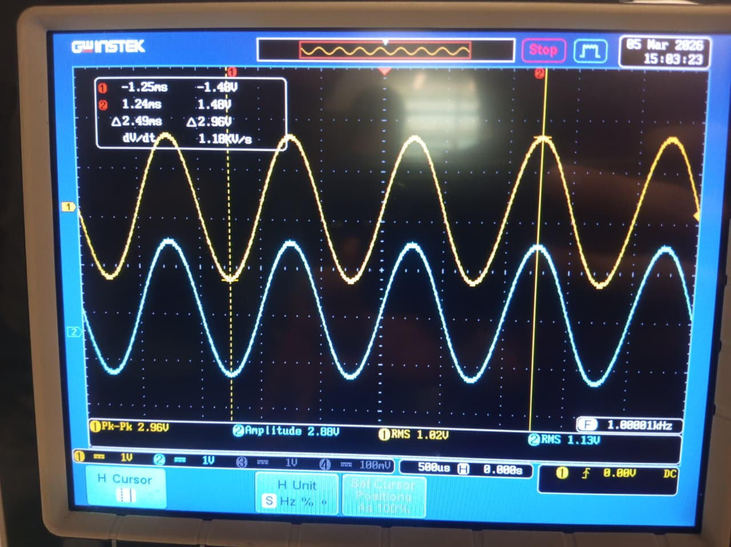

Amplifier Input Impedance: Zi
- To determine the input impedance of this amplifier, connect an input measurement resistor, Rx=10kΩ, as shown in Figure 4. Apply the AC input signal of 2Vrms at frequency of 1 kHz but this time through this known resistance. Measure Vi which is the signal after this resistor Rx input to amplifier. Note down in Table 3.
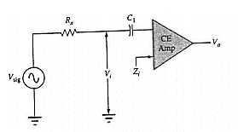
Figure 4: Circuit for determining input impedance

- Mathematically, for this circuit this voltage Vi can now be expressed as
Solve the given equation for Zi.
$\frac{V_{i}R_{x}}{V_{sig}-V_{i}}$
- Determine the value of input impedance. Note down in Table 3.
Table 3: Experimentally determined values of CC amplifier characteristic parameters
Characteristic Parameter | Experimentally Determined Values | Required Measurements | Measured Values
CC Amplifier Voltage Gain: Av | 0.989 | Input Voltage: Vi | 760 mVrms
CC Amplifier Voltage Gain: Av | 0.989 | Output Voltage (Unloaded): Vo | 752 mVrms
CC Amplifier Input Impedance: Zi | 7.161 kOhms | Measurement Resistor: Rx | 9.8k
CC Amplifier Input Impedance: Zi | 7.161 kOhms | Source Voltage: V _{Sig} | 1.8Vrms
CC Amplifier Input Impedance: Zi | 7.161 kOhms | Input Voltage: Vi | 760 mVrms
CC Amplifier Output Impedance: Zo | 21.94 Ohms | Output Voltage Unloaded: Vo | 104 mVrms
CC Amplifier Output Impedance: Zo | 21.94 Ohms | Load Resistor: R_{L} | 98.18
CC Amplifier Output Impedance: Zo | 21.94 Ohms | Output Voltage Load: V_{L} | 80.5 mVrms

Amplifier Output Impedance: Zo
- Remove the input measurement resistor Rx.
- Apply AC input signal (100 mV rms at 1 kHz) directly. Measure the unloaded output voltage Vo.
- Now, connect load resistor of 100 Ω and measure the corresponding loaded output voltage V_{L}. Note it down in Table 3.
- When loaded, the output voltage can be expressed as
Solve the above for output impedance Zo.
$\frac{R_{L}(V_{o}-V_{L})}{V_{L}}$
- Calculate the output impedance to complete Table 3.

Transistor as a Switch
Transistor can be used as a switch to control the ‘on’ and ‘off’ states of a load. The behavior of switch is represented in Figure 5. When a switch is off, it can be replaced by open circuit and when it is fully on, it can be replaced by short-circuit.
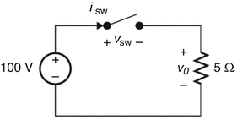 | 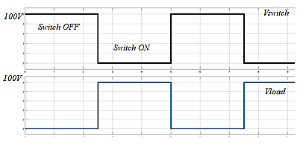
Figure 5: Characteristics of ideal switch
For implementation of switch by transistor, the transistor operates in saturation region and cut-off region. In cut-off region, both the junctions remain reversed-biased so it acts as “fully-OFF” and in saturation region, both the junction remain forward-biased so it acts as “fully-ON”. In common-emitter configuration, the voltage across collector-emitter terminal is equal to the supply voltage Vcc in cut-off region and in saturation region, collector-emitter voltage remains approximately equal to zero (0.3 V). Therefore, the base terminal can be used to control the operation of transistor switch that can control the state of load connected at collector terminal. The collector and emitter form the switch terminals and the base is the switch handle. In other words, the small base current can be made to control a much larger current between the collector and emitter. For example, the circuit of Figure 6 can be modified to control an electric motor. The BJT switch only needs to handle the small base current due to the current amplification provided by the transistor. If high current motors are directly switched on and off, mechanical switch contacts will eventually wear out from switching the high current, causing the switch to fail. However, the BJT can operate nearly indefinitely as the switch as it has no mechanism that causes it wear out. The loads that require a few milliamps can be directly controlled by connecting them at collector terminal. For devices that require more power like large motors, the transistor switch can be used to control relay (as relay driver) that controls motor.
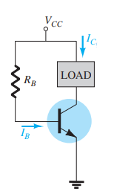 | 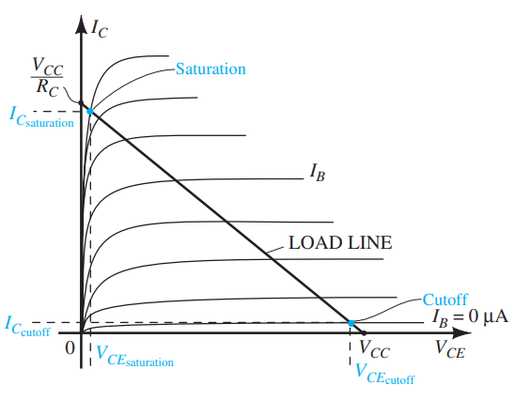
Figure 6: Transistor as switch
When EBJ is forward biased, let V_{BE} be 0.7 V. We know that when collector voltage is lower than the base voltage by 0.4V, the transistor enters saturation region. For that edge of saturation (EOS) point, we can take V_{C} equal to 0.3V. For a transistor that operates deeper into saturation region, we take V_{CE_sat} equal to 0.2V.
Using minimum value of current gain β_{min}, corresponding edge-of-saturation base current I_{B (EOS)} required to saturate the transistor is given by
In saturation region, the transistor can be forced to operate at any desired β. The ratio of collector (in saturation) to base current is therefore, called β_{forced}. Ratio of I_{B} to I_{B_Sat} is called overdrive factor. This can be used to calculate required base current and resistance R_{B}.

Task 5: To design circuit for implementing BJT switch to control an LED
To design a circuit that utilizes transistor as a switch for controlling on and off status of Red LED, consider the circuit shown in Figure 7. Here, in series with LED, there is a current limiting resistor $R$. The LED forward voltage is 2V and has forward current rating of 20mA. The LED with current limiting resistor will act as load across which 5V should appear when the switch is on and 0V when switch is off.
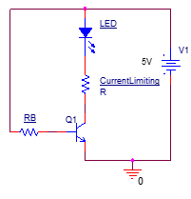
Figure 7: Implementation of transistor switch to control LEDFind the value of current limiting resistor $R$ and base resistor $R_{B}$with β_{min} of 100 and an overdrive factor of at least 10. Show your calculations. Hint: Use equations derived in Task 1.
Given Information:
- Supply voltage: V_CC = 5V
- LED forward voltage: V_LED = 2V
- LED forward current rating: I_LED = 20mA
- β_min = 100
- Overdrive factor = 10
- V_BE = 0.7V (when forward biased)
- V_CE_sat = 0.2V (transistor in saturation)
Step 1: Calculate Current Limiting Resistor R
When the transistor switch is ON (saturated), the LED and resistor R are in series between V_CC and the collector. Using Kirchhoff's Voltage Law (KVL) around the collector loop:
Vcc = Vled + Vresistor + Vsaturation
Where V_R is the voltage across resistor R.
Solving for V_R:
- V_R = V_CC - V_LED - V_CE_sat
- V_R = 5V - 2V - 0.2V
- V_R = 2.8V
The collector current equals the LED current (since they're in series):
- I_C = I_LED = 20mA = 0.02A
Using Ohm's Law to find R:
- R = V_R / I_C
- R = 2.8V / 0.02A
- R = 140Ω
Step 2: Calculate Base Current at Edge of Saturation (EOS)
The minimum base current needed to just saturate the transistor is:
I_B(EOS) = I_C / β_min
- I_B(EOS) = 20mA / 100
- I_B(EOS) = 0.2mA = 200µA

Step 3: Apply Overdrive Factor to Calculate Actual Base Current
To ensure the transistor operates deep in saturation (not just at the edge), we apply an overdrive factor:
I_B = Overdrive Factor × I_B(EOS)
- I_B = 10 × 0.2mA
- I_B = 2mA = 0.002A
This ensures β_forced = I_C / I_B = 20mA / 2mA = 10, which is much lower than β_min = 100, guaranteeing saturation.

Step 4: Calculate Base Resistor R_B
When 5V is applied at the input (switch ON), using KVL in the base loop:
V_in = I_B × R_B + V_BE (from prelab)
Solving for R_B:
- R_B = (V_in - V_BE) / I_B
- R_B = (5V - 0.7V) / 0.002A
- R_B = 4.3V / 0.002A
- R_B = 2.15kΩ
We can use a standard resistor value of 2.2kΩ (closest standard value).

Task 6: To implement and investigate operation of BJT switch for LED control

- Construct the circuit designed in Task 5 using 2N3904 BJT.
- Identify the modes of operation of transistor when voltage is applied at base terminal through
$R_{B}$ and when the applied voltage at this terminal is 0V. Don’t change the voltage $V_{CC}$ applied at load. Observe the status of LED Measure the voltage across the load (LED + Resistor) and transistor switch in each case along with base current and collector current.
Mode of Operation | (Saturation region) @ Vcc=5V | (Cut off region) @ Vcc=0V
$$V_{LOAD}=V_{(LED+R)}$$ | 4.934V | -18.67V
$$I_{C}$$ | 17.42mA | 0uA
$$I_{B}$$ | 1.90mA | 0.20uA

- Now, instead of controlling transistor switch through constant supply at base terminal, control it through a pulse signal with 50 % duty cycle having amplitude of 5V. Use the function generator to generate 1Hz square wave of 0-5V (5V peak to peak and offset of 2.5V). Why is offset added?
Instead of applying constant DC voltage to the base, the transistor was controlled using a square wave pulse signal from the function generator.
The signal used was:
- Frequency: 1 Hz
- Amplitude: 5 V peak-to-peak
- Offset: 2.5 V
The offset is added so that the signal varies between 0V and 5V.
Without the offset, the square wave would swing between +2.5V and −2.5V, which would apply negative voltage to the base and could damage the transistor or cause incorrect operation.
With the offset:
- LOW level = 0V → transistor OFF
- HIGH level = 5V transistor ON
Because of this, the LED turns ON and OFF periodically, following the input pulse.

- Initially set frequency of 1Hz and then increase it. Does the transistor switch keep changing its status at higher frequencies? You can verify this by observing glow of LED and obtaining voltage waveform across transistor switch / load.
Initially at 1 Hz, the LED clearly turned ON and OFF every second.
As the frequency was increased:
- The transistor continued switching correctly.
- However, at higher frequencies the LED appeared continuously ON.
This happens because the human eye cannot detect very fast blinking, so the LED looks constantly lit even though it is still switching.

Post Lab Task

Task 7: To analyze the performance of BJT as amplifier and switch
- Discuss the application of emitter-follower circuit as voltage buffer.
Application of Emitter-Follower as a Voltage Buffer
The emitter-follower circuit is commonly used as a voltage buffer. In this configuration, the output voltage at the emitter is almost equal to the input voltage applied at the base (slightly lower by about 0.7V).
The main advantage of this circuit is that it provides:
- Very high input impedance
- Very low output impedance
Because of this property, it can connect a high impedance source to a low impedance load without significantly affecting the signal. In other words, it prevents loading effects and allows efficient signal transfer between stages.
For example, it is often used between sensor circuits and signal processing circuits, or between amplifier stages.

- Compare characteristic parameters of CE amplifier and CC amplifier.
Parameter | CE Amplifier | CC Amplifier (Emitter Follower)
Voltage Gain | High (>1) | Approximately 1
Phase Shift | 180° (inverted) | 0° (no inversion)
Input Impedance | Moderate | Very High
Output Impedance | High | Very Low
Main Application | Voltage amplification | Voltage buffering / impedance matching

Assessment Rubric
Lab 07
BJT as Switch and Emitter-Follower Amplifier
Name: | Student ID:

Points Distribution

Task No. | LR1  Circuit Layout | LR 4  Data Collection | LR 6  Calculation | LR 10  Analysis | LR 11  Design
Task 1 | - | - | - | - | /8
Task 2 | /4 | /10 | - | - | -
Task 3 | - | - | /8 | - | -
Task 4 | /4 | /12 | /4 | /8 | -
Task 5 | - | - | - | - | /8
Task 6 | /4 | /8 | - | /8 | -
Task 7 | - | - | - | /10 | -
 | /12 | /30 | /12 | /26 | /16
CLO Mapped | CLO 1 | CLO 1 | CLO 1 | CLO 1 | CLO 2

Affective Domain Rubric |  | Points | CLO Mapped
AR 4 | Report Submission | /4 | CLO 4

CLO | Total Points | Points Obtained
1 | 80
2 | 16
4 | 04
Total | 100

For description of different levels of the mapped rubrics, please refer the provided Lab Evaluation Assessment Rubrics and Affective Domain Assessment Rubrics.

